Wakefield Siding/Trim Color Palette

The purpose of this document is to update and expand the Wakefield Estates HOA approved color palette for siding/trim and assist in the process of completing a required Architectural Change Request (ACR) Form for siding related projects.

Most homes in Wakefield were constructed using,

Product: Norandex Woodsman Select (Early Profile) (Discontinued)
Profile: Double 5” Dutch Lap
Thickness: 0.042”
Projection: 0.5”
Material: Vinyl
Manufacturer: www.norandex.com

Due to differences in construction and the discontinuation of the existing siding, many homeowners may be unable to repair their existing siding with the current version being produced by the manufacturer. As a result, several homeowners in Wakefield Estates and its sister neighborhoods have made the decision to upgrade from the basic quality siding used in the construction of the home to that of higher quality when faced with the need for repairs.

The HOA has made the decision to update and expand the existing color palette to better reflect the changing architectural style and modernity of siding materials available, to give Wakefield homeowners greater choice and guidance when planning siding replacement and repairs. The HOA would like to enable any resident that would like to improve upon the quality of their property to be able to do so with limited interference from the HOA. However, it is important to remember that the HOAs purpose is to help maintain general standards of uniformity and provide for the protection of all homeowner’s property values. As such, any siding replacement or repair using materials other than those used in the construction of the property must be approved by the Architectural Change Committee prior to the start of construction.

This document will further detail three different siding products in a Good, Better, Best ranking to provide a basic guide to modern siding products and their updated color palate. Wakefield homeowners are free to research any siding manufacturer and are not limited to the use of any specific products contained herein. These products have been used as the basis for the expanded color palate and the examples in this document belong to products highlighted.

Good:

Product: | Norandex Woodsman Select
Profile: | Double 4” Dutch Lap, Double 5” Dutch Lap, Double 4” Clapboard, Double 5” Clapboard
Thickness: | 0.042”
Projection: | 0.625”
Material: | Vinyl
Manufacturer: | https://www.norandex.com/media/1843/woodsmanselectlit2019web.pdf  https://www.norandex.com/media/1856/woodsman-select-coc.pdf

Better:

Product: | CertainTeed Monogram
Profile: | Double 5” Dutch Lap, Double 4” Clapboard, Double 5” Clapboard
Thickness: | 0.046”
Projection: | 0.75”
Material: | Vinyl
Manufacturer: | https://www.certainteed.com/resources/Monogram_2021_Final.pdf  https://www.certainteed.com/resources/MonogramConsumer_Brochure_CTS456_2101_E.pdf

Best:

Product: | James Hardie HZ5 HardiePlank
Profile: | 4”, 5”, 6”, 7”, 8”
Thickness: | 5/16”
Projection: | See Thickness
Material: | Fiber Cement
Manufacturer: | https://www.jameshardiepros.com/#product-catalog-download  https://www.jameshardiepros.com/getattachment/9a1017e1-853d-4574-b3e9-7afb1a5a472d/intro-tools-hz5-us-en.pdf

Color Palette

White:
Arranged lightest allowed to darkest allowed.
Anything in between may be submitted for approval as well.




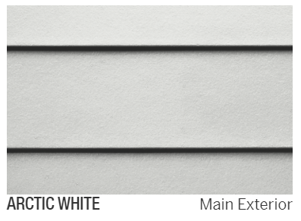

Silver/Gray:
Arranged lightest allowed to darkest allowed.
Anything in between may be submitted for approval as well.







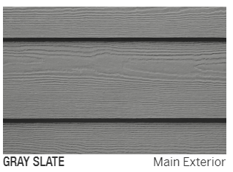
Yellow/Beige:
Arranged lightest allowed to darkest allowed.
Anything in between may be submitted for approval as well.





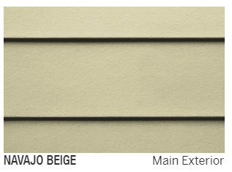

Sand/Tan:
Arranged lightest allowed to darkest allowed.
Anything in between may be submitted for approval as well.






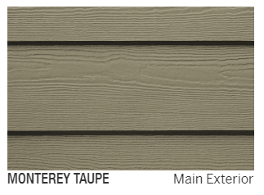

Blue:
Arranged lightest allowed to darkest allowed.
Anything in between may be submitted for approval as well.

Wedgewood


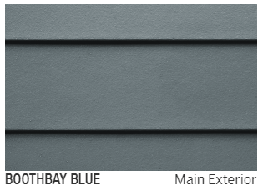



Green:
Arranged lightest allowed to darkest allowed.
Anything in between may be submitted for approval as well.






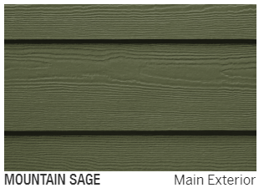

Shutters, Doors, & Trim:
Shutter, Doors, & Trim should be complementary to the overall appearance of the property and the neighborhood. Homeowners should include a color sample for shutters, doors, & trim to be used in conjunction with siding replacement for approval along with their ACR.
Garage Door:
Garage doors should be complementary to the overall appearance of the property and color changes should be limited to white, the color of the siding, or be approved of in advance by ACR.
Gutters:
Gutters should be white, or a complementary color approved of in advance by ACR. It is recommended that gutter downspouts be 8’ away from the home’s foundation.
Roofing:
Roofing colors should be complementary to the overall appearance of the property and the neighborhood. Due to the wide variation in roofing colors, all roofing changes need to be approved in advance by ACR and should be accompanied by a color sample.

Summary:
The goal of the Architectural Change Committee in updating this document is to give Wakefield Estates Homeowners greater liberty and freedom of expression for their individual property. However, it is important for the ACC to maintain the ability to provide oversight and guidance to the appearance of homes in the neighborhood to enhance Wakefield Estates Homeowners property values. Due to the broader scope of product and color options there is an increased likelihood that your considered changes may need an Architectural Change Request Form (ACR).
The usage of any specific color scheme is not guaranteed by the ACC, Wakefield Estates HOA, or the HOA’s contracted property manager. The products &/or colors included in this document are not the only products &/or colors a homeowner may choose. Any proposed color scheme or construction proposal should seek to help maintain the general style of construction and color scheme of the neighborhood. Please complete and submit an ACR prior to ordering materials from your contractor.
ACR forms can be found in your homeowner portal provided by the management company.

